Example: Custom Exception class referring to OTR
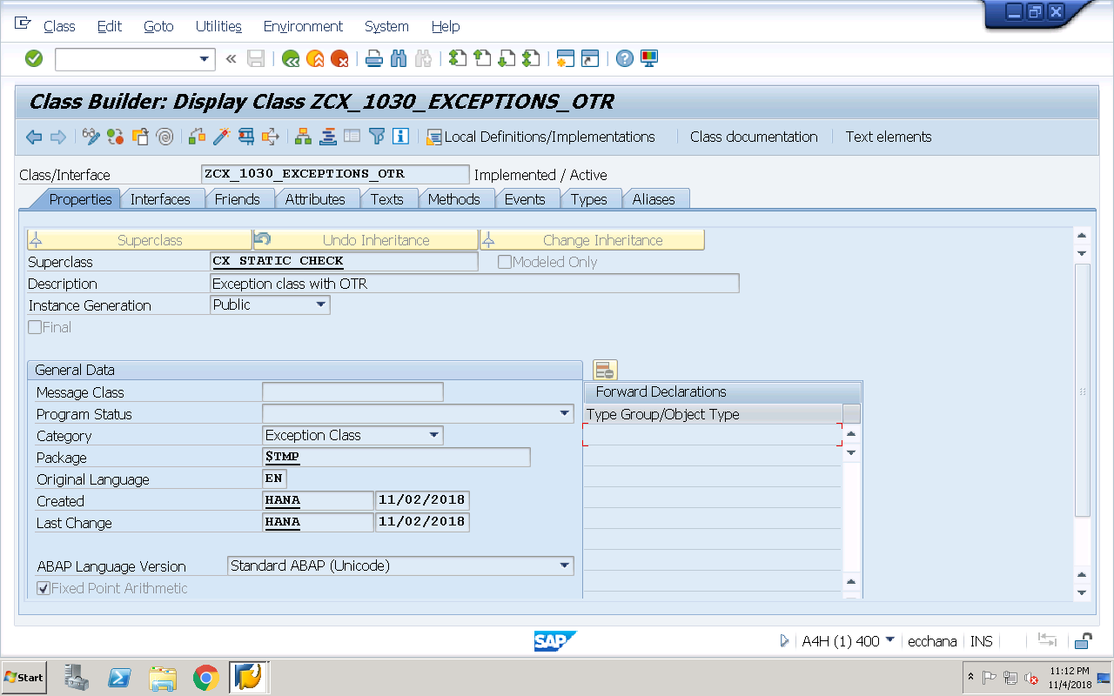
Create Exception ID’S ID1 and ID2 in Texts tab and maintain short text
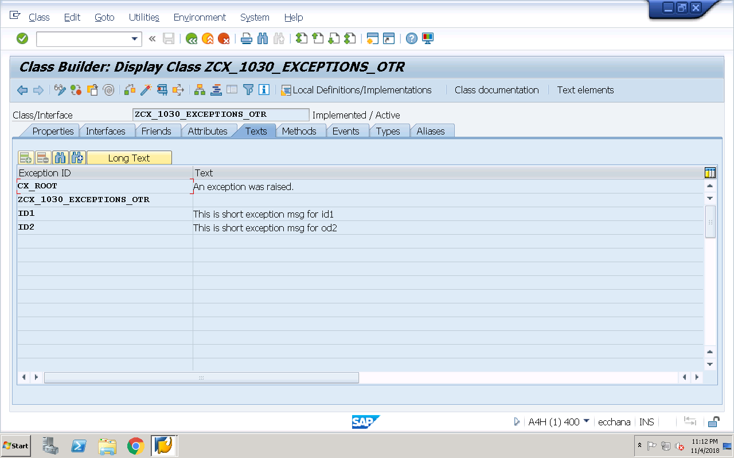

Maintain Long text for Exception ID ID1
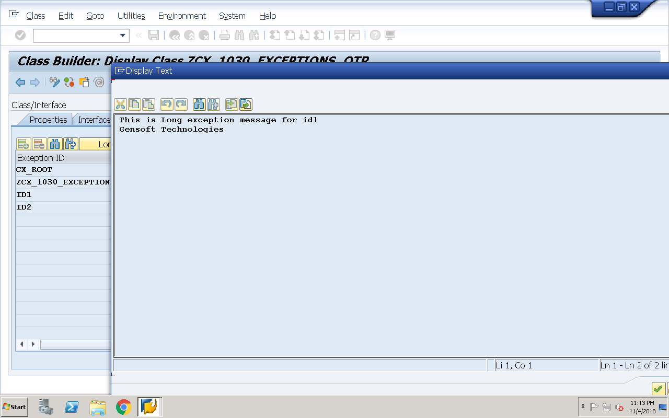
Save, Check and activate the Global class
Executable program: For raising exceptions from custom exception classes referring to OTR
REPORT Z1030OOPS30.
data v_msg type string.
data ob type ref to zcx_1030_exceptions_otr.
try.
RAISE EXCEPTION TYPE zcx_1030_exceptions_otr
EXPORTING
textid = zcx_1030_exceptions_otr=>id1.
catch zcx_1030_exceptions_otr into ob.
CALL METHOD ob->if_message~get_text
RECEIVING
result = v_msg.
write :/ 'Short exception msg for id1 is ',v_msg.
clear v_msg.
CALL METHOD ob->if_message~get_longtext
RECEIVING
result = v_msg.
write :/ 'Long exception msg for id1 is ',v_msg.
endtry.
uline.
try.
RAISE EXCEPTION TYPE zcx_1030_exceptions_otr
EXPORTING
textid = zcx_1030_exceptions_otr=>id2.
catch zcx_1030_exceptions_otr into ob.
CALL METHOD ob->if_message~get_text
RECEIVING
result = v_msg.
write :/ 'Short exception msg for id2 is ',v_msg.
clear v_msg.
CALL METHOD ob->if_message~get_longtext
RECEIVING
result = v_msg.
write :/ 'Long exception msg for id2 is ',v_msg.
endtry.

Example: Custom Exception class referring to Message class
Create a message class (z1030msg) in SE91 with static and dynamic message
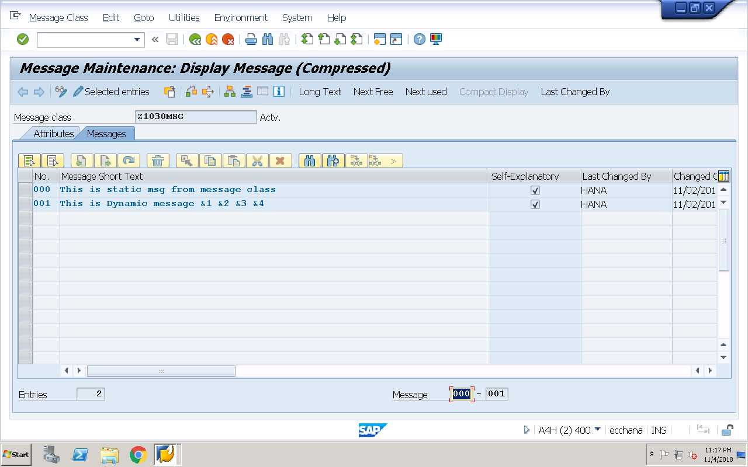
Save the message class
Now, create the exception class in se24 by selecting the checkbox ‘message class’
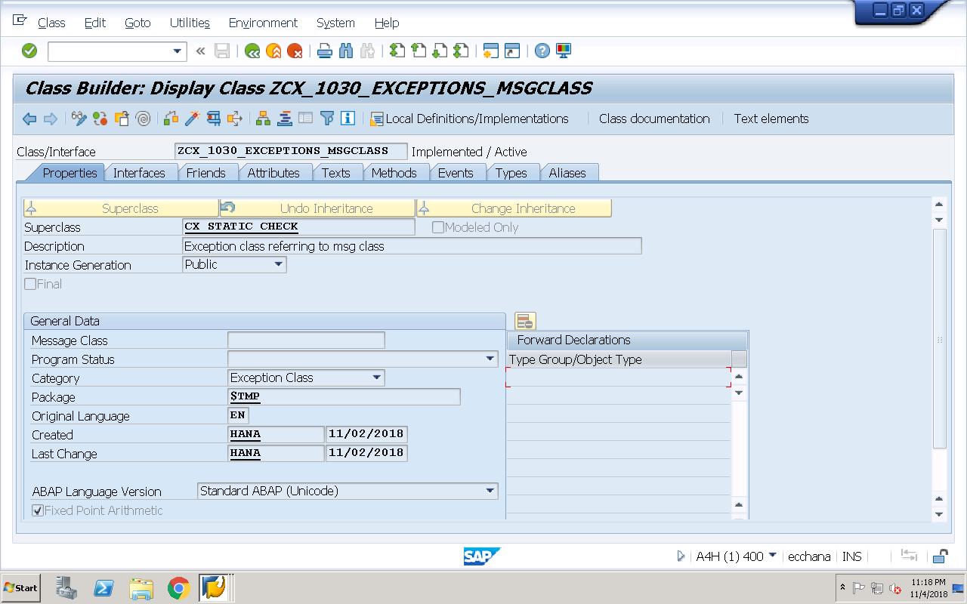

Create 4 attributes ATTR1, ATTR2, ATTR3, ATTR4 in Attributes tab
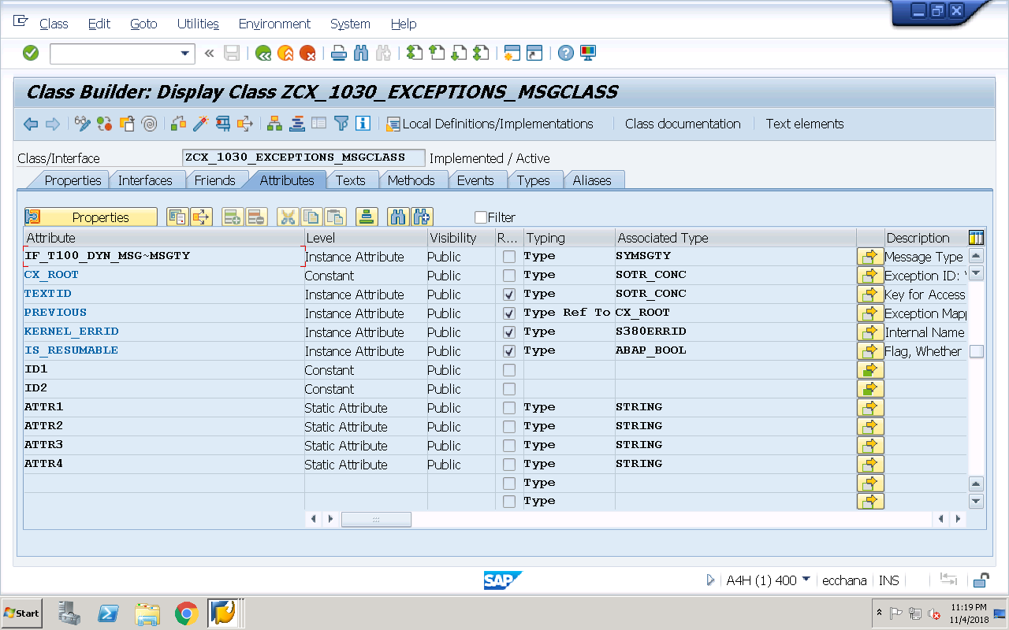
In Texts tab, Create Exception ID’s ID1 and ID2 and link ID1 with static message 000 of message class and link ID2 with dynamic message 001 of message class (While linking with dynamic message 001, map the 4 holders with corresponding 4 attributes)
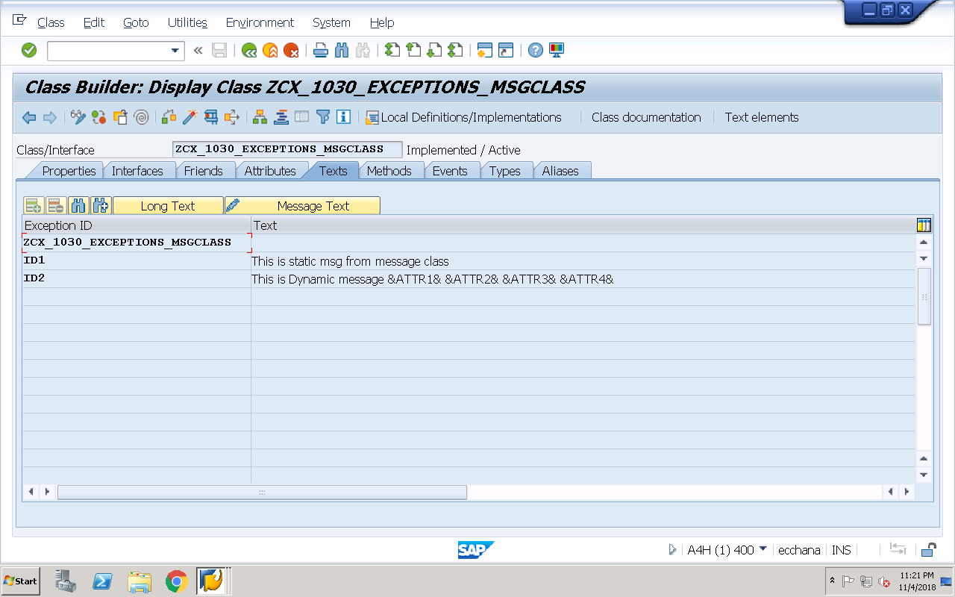
Save, check and activate the global class

Executable program: For raising exceptions from custom exception classes referring to message class
REPORT Z1030OOPS31.
data v_msg type string.
data ob type ref to zcx_1030_exceptions_msgclass.
try.
RAISE EXCEPTION TYPE zcx_1030_exceptions_msgclass
EXPORTING
textid = zcx_1030_exceptions_msgclass=>id1.
catch zcx_1030_exceptions_msgclass into ob.
CALL METHOD ob->if_message~get_text
RECEIVING
result = v_msg.
write :/ 'Short exception msg for id1 is ',v_msg.
clear v_msg.
CALL METHOD ob->if_message~get_longtext
RECEIVING
result = v_msg.
write :/ 'Long exception msg for id1 is ',v_msg.
endtry.
format color 3.
try.
RAISE EXCEPTION TYPE zcx_1030_exceptions_msgclass
EXPORTING
textid = zcx_1030_exceptions_msgclass=>id2
attr1 = 'Gensoft Technologies'
attr2 = 'Ameerpet'
attr3 = 'Hyderabad'
attr4 = 'Telangana,INDIA'.
catch zcx_1030_exceptions_msgclass into ob.
CALL METHOD ob->if_message~get_text
RECEIVING
result = v_msg.
write :/ 'Short exception msg for id1 is ',v_msg.
clear v_msg.
CALL METHOD ob->if_message~get_longtext
RECEIVING
result = v_msg.
write :/ 'Long exception msg for id1 is ',v_msg.
endtry.

